Great Lakes Aquatic Tissue Analysis Repository (GLATAR) is used to compile data on energy densities, stable isotope, thiamine (vitamin B), fatty acid, and other data for species in freshwater systems.
If you require more information, please contact Ben Hlina (benjamin.hlina@gmail.com) or Tim Johnson (tim.johnson@ontario.ca) for further clarification.

Table of Contents
- Template & Paper Selection
  - Standard vs. Long
  - Where to Obtain Templates
  - Data Sourcing
  - Out-of-Scope papers
  - Unusable papers
- Tbl_sources
  - Author Information
  - Email
  - Pages
  - Publishing Information
- Tbl_samples
  - Sample Date
  - Taxonomic Information
  - Sex
  - Life stage
  - Tbl_location
  - Tbl_calorimetry
  - Tbl_Proxcomp
  - Tbl_isotope
  - Tbl_fatty_acid
  - Tbl_amino_acid
  - Tbl_thiamine
  - Tbl_contaminants
- GLATAR
  - Registration
  - Navigation
  - Taxonomic Search Tool
  - Species Submission
  - Data Sheet Submission

1. Template & Paper Selection
1.1. Basic Vs. Extended
There are two template versions available for GLATAR data entry. These are the basic and extended versions. The two are identical, except for a few additional columns in the extended. The basic template does not have columns for overall lipid composition, fatty acids, amino acids, thiamine, or contaminants (i.e. mercury, PCB, congener). It is recommended that the basic template be used unless entering a paper involving the aforementioned data types. This will reduce unnecessary complexity.
1.2. Where to Obtain Templates
Data from articles is entered through the data entry template are on the GLATAR website, found by going to the ‘Documentation’ tab and downloading either the Basic Data Entry Template (v21) or the Extended Data Entry Template (v21), depending on needs. 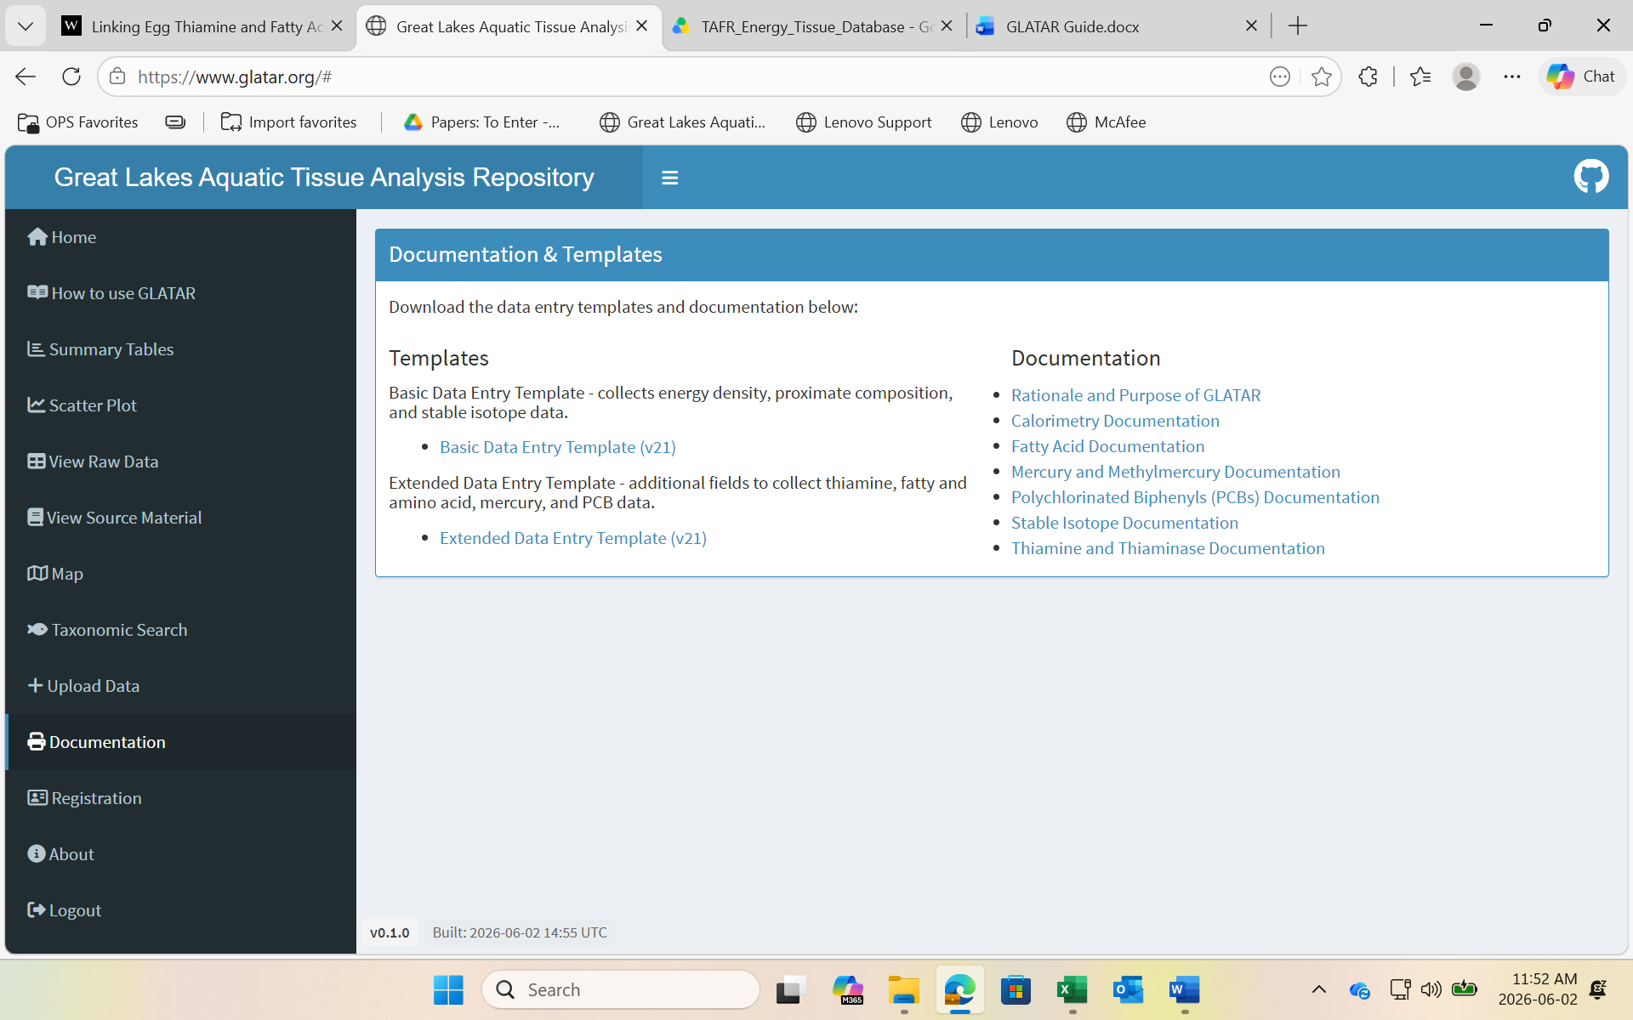
1.3. Data Sourcing
Data must be extracted from an appropriate source that is relevant to GLATAR. A compiled list of potentially useful papers may be found in a shared Google Drive dedicated to GLATAR, titled “TAFR_Energy_Tissue_Database”. If you do not have access to this drive, ask Tim Johnson (tim.johnson@ontario.ca) or Ben Hlina (benjamin.hlina@gmail.com) for access. Once in the drive, go into the folder “Papers: To Enter”. The list is found in an excel sheet, titles “Selected_recs_KS_lit_review_2026-02-16.xlsx”.
1.4. Out-of-Scope papers
Not all papers in the list of selected paper recommendations will be within the scope of GLATAR. As its name suggests, this repository is largely aimed at compiling data from the Great Lakes. However, the range has been expanded to include all bodies of fresh water in North America. Data from bodies of saltwater are NOT viable for this purpose.
Furthermore, this repository is intended largely for aquatic animal tissue. Avoid entering data on plants, with the exception of phytoplankton (protists). Animals of concern include fish and aquatic invertebrates. Birds and mammals are not currently within the scope of GLATAR.
If you come across a paper that you believe to be out-of-scope, flag it and, if possible, download a PDF version of it to upload to the “Papers: Outside Scope” folder in the shared Google drive. If you are unsure of whether the paper will serve GLATAR’s purposes, consult Blen Hlina or Tim Johnson for confirmation.
1.5. Unusable papers
Papers using data collected on saltwater or marine ecosystems should be avoided, in addition to any papers that do not fit any of the needs of the GLATAR form (i.e. does not contain information regarding thiamine, fatty acids, energy densities, stable isotopes, etc.).
One example of this may be a paper that has its stable isotope data expressed as a ratio between two elements, rather than the raw data. As a reminder, double check if the article provides a link to supplemental data, which may include the necessary data.

2. Tbl_sources
2.1. Author Information
When inputting authors’ names into the ‘author_names’ and ‘pi_name’ columns, ensure to follow the format of last name, followed by a comma, and first (and middle if available) initials. For example, Timothy B. Johnson would be entered as: Johnson, T.B., separated by a comma from other authors. When listing multiple authors, the primary investigator should come first. It is usually a safe bet to follow the order listed on the paper itself. The primary investigator is almost always listed first.
2.2. Email
Some papers, like those that were published a long time ago, will not have a contact email attached. If this is the case, list john.doe@gmail.com in place of the contact email.
2.3. Pages
This column is asking for a range of page numbers (e.g. 123-132), not the total number of pages of the paper (e.g. 9).
2.4. Publishing Information
Information, such as publisher, editor, and isbn are not relevant to scientific journal papers. These columns are in place for information coming from a book. However, the journal name, volume, issue, and DOI, are useful information if available from a scientific paper.

3. Tbl_samples
3.1. Sample Date
If a sample date is provided, enter it into the spreadsheet with as much detail as possible: year, day, month, season. Keep in mind that months should be entered as a numerical value rather than the full month name or abbreviation.
If a more general range of dates is provided, enter the data as follows:
- Year Ranges: If sampling occurred over the span of a few years, duplicate the data so that it exists for every year in a separate row. For example, if a paper averaged energy densities from fish collected between 2005-2007, copy and paste the mean data into three rows, only changing the year for each one.
- Month Ranges: If sample collection took place over multiple months, enter the middle month as a numerical value into the month column. For example, if sampling took place from April (4) – June (6), enter the month as May (5). If the data is collected only over the span of two months, enter each month separately and replicate the data so that each month is represented like you would do with a range of years.
- Seasons: If sampling took place during a clear season, enter that season. Otherwise, if sampling occurred throughout spring and summer, for example, do not enter season, simply leave that column blank.
3.2. Taxonomic Information
It is essential to enter the common and species names into their respective columns for each line of data entry. However, it is not necessary to input the genus and family names. GLATAR has a tool for this and thus it would be redundant and unnecessary to enter extensive taxonomic information.
3.3. Sex
This column presents a drop-down menu, with the options to select female, male, both, or unknown. In the event that a paper does not mention the sex(es) of its samples, it should be assumed that both sexes were included in the sample. If the sample could not be sexed, for example if it was an egg sample, then the sex should be inputted as ‘unknown’.
3.4. Life Stage
The life stage column has a drop-down menu that holds options for different life stages. If the sample in question is a phytoplankton or invertebrate, these options may not properly correspond with the life stages, so this section can be left blank in that case.
The wild_lab column is used to enter whether the fish were caught in the field or raised in a lab, which is typically mentioned in the paper.
3.5. Tbl_location
There are several categories for entering the location of sampling on the GLATAR data sheets. These include location, waterbody, area, and site.
- Location refers to the broader area of sampling, for example the province or state where samples were collected, ie. Ontario, Canada or Michigan, United States.
- Waterbody is the waterbody where samples were collected, ie Lake Ontario or Lake Madison.
- Area is the more specific location within the waterbody where sampling took place, i.e. a specific channel within the waterbody
- Site should contain numbers only, and it is used if the paper uses a numbering system for separating sites where samples were collected.
Some examples:
- Sampling occurred in Lake Ontario, use coordinates from the middle of the lake
- Sampling occurred on the US side of Lake Ontario, use coordinates from the middle of the US side of Lake Ontario
- If for one sample, there were more than 1 site provided use your intuition and select the coordinates that represent the centre point.
- Check whether the paper mentioned if data was collected near shore or deeper in the water body and choose coordinates accordingly. For Example: Channel catfish Sampled from Lake Erie's Western Basin, Central Basin and Rondeau Bay. choose the centre point between these three areas.
If coordinates are not provided for the sampling site(s), use Google Earth to approximate the coordinates. Additionally, coordinates should be entered in decimal degree forma to a maximum of 5 decimal places. If uncertain about the conversion between formats, use an online latitude longitude converter like Latitude Longitude Converter - Latitude Longitude Data.
3.6. Tbl_calorimetry
This section is used when a paper is focused on calorimetry, which can include data on energy densities. If a calorimetric method is mentioned, indicate it by choosing the corresponding option on the dropdown menu under the calorimetry_method column.
For energy densities, ensure that units are in Joules/g and do the proper conversions if necessary. Other columns may ask for information that is found on the graph rather than explicitly mentioned (although be sure to check if there is a supplemental data page, because extra information could be listed there). If this is the case, download PlotDigitizer, where you can upload the plot to get information like intercept and slope.
3.7. Tbl_Proxcomp
In the tbl_proxcomp section, it is measuring the percent content of different sample measurements including water, carbon, lipids, and proteins. Ensure that the data entered is a percentage.
3.8. Tbl_isotope
There are several categories for isotope data input. For example, Carbon 13, Carbon 15, Sulfur 34, oxygen 18, hydrogen 2 and carbon/nitrogen ratio. There is also an isotope-lipid correction column which can be found from the paper. Some papers adjust the isotope values to compensate for lipid which affects the isotope signatures.
NB: Normalising data or correcting data using Carbon/Nitrogen ratio assumes the carbon data is Lipid Free.
NB: If a range is given, choose the average value.
NB: Isotope data are to be noted within 2 decimal places and are expressed as percentages.
3.9. Tbl_amino_acid
If a paper reports data on multiple types of amino acid in a sample, a new row must be created for each. Each row should be identical, apart from the amino acid columns. Repeat this for every sample with data for more than one amino acid type. This process can be made simpler in the Excel sheet by dragging a datum downward through each row of the column pertaining to the sample at hand.
Measurements for amino acids should be entered in µg/mg sample weight or percentage of total protein of the sample.
3.10. Tbl_thiamine
The column thiamine_type will give the drop-down options of Th (free thiamine), TMP (thiamine monophosphate), TPP (thiamine pyrophosphate), and TTh (total thiamine)). If the type of thiamine is not specified in the paper, enter it as total thiamine. If multiple types of thiamine are reported in the paper, create a new line for each. As previously stated, each row should be identical but for the thiamine column(s).
3.11. Tbl_contaminants
Possible contaminants for entry are shown in the columns of tbl_contaminants. These include mercury, PCBs, and PCB congeners. When entering contaminant data, it is critical to make a distinction between PCBs (Polychlorinated Biphenyls) and PCB congeners. PCBs are a broad class of synthetic chemical compounds, while a PCB congener refers to any single, specific chemical compound within that class.

4. GLATAR
4.1. Registration
Registration on the GLATAR website is essential for full use of the website (e.g. data submission, viewing raw data, new species submission). To do this, click on the Registration tab on the toolbar to the left of the website. When prompted, enter your name, MNR email, and affiliation (Ministry of Natural Resources). Shortly afterwards, you should receive a confirmation email to finalize your registration.
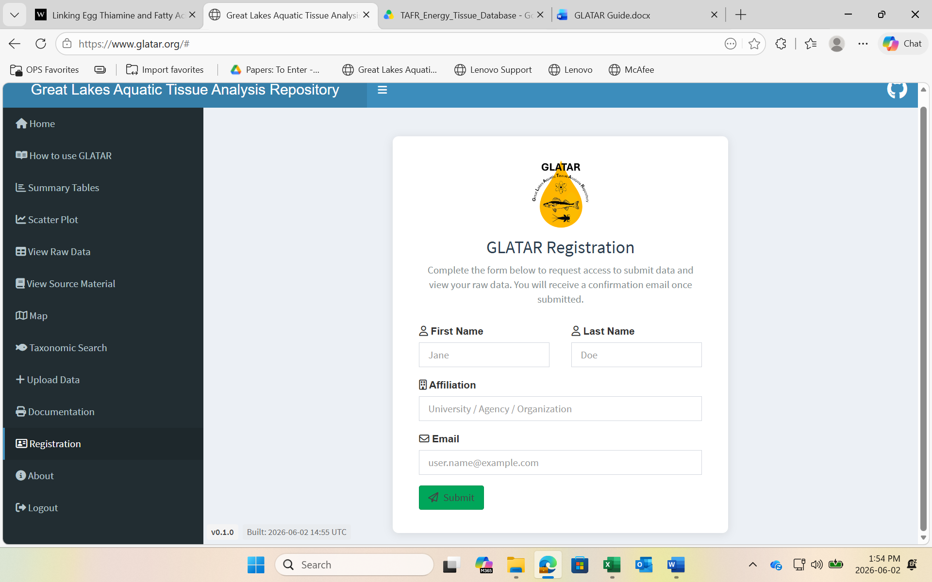
4.2. Navigation
When first introduced to GLATAR, it can be helpful to take some time and ‘mess around’ on its website. There are numerous tools available on this website that can be useful for ARMS staff, even beyond data entry.
Upon opening the app, the first tab beneath the home tab is labelled How to Use GLATAR. This page will provide the essential rundown of how to navigate the website’s numerous tools.
4.3. Taxonomic Search Tool
The taxonomic search tab is a handy way of seeing which species have been included in the database. It provides detailed information on taxonomic classification.
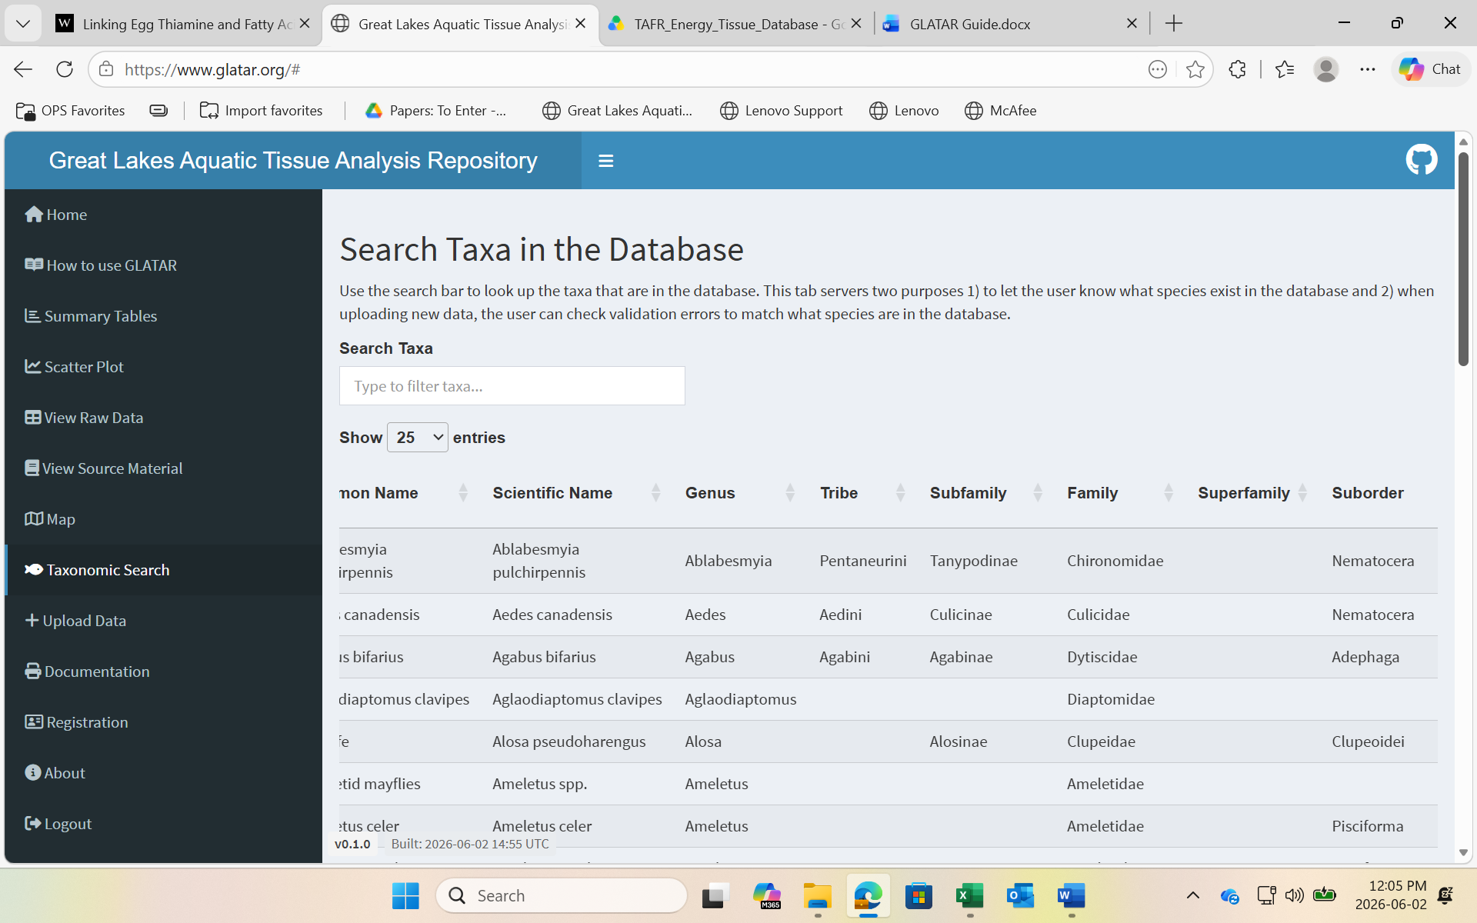
4.4. Species Submission
If the article you are uploading includes a species which does not currently exist in the GLATAR database, you can submit a request to add the species.
To do so, go to the bottom of the Taxonomic Search tab on the GLATAR website, and under ‘Suggest Taxa to the Database,’ fill out the information to the best of your abilities. Keep in mind, species that are terrestrial species or plants, with the exception of phytoplankton, should not be added to the database.
To submit a species, you must first be registered on GLATAR.
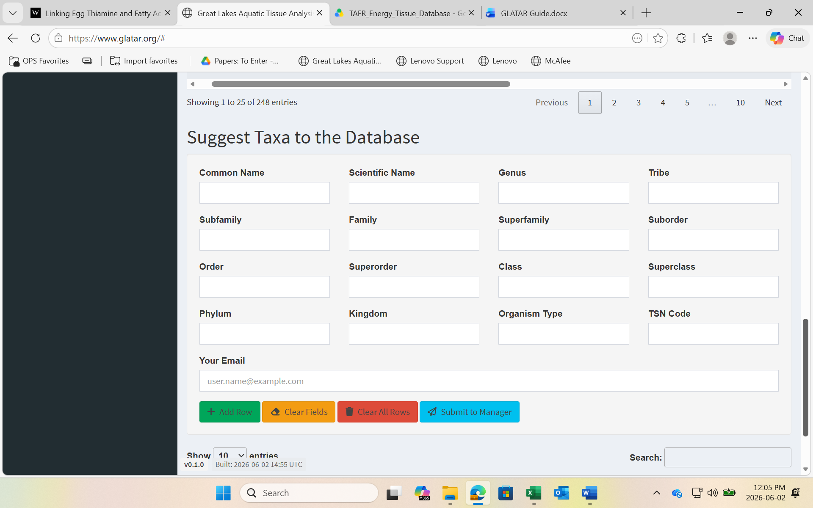
4.4. Data Sheet Submission
Once you have entered a number of papers on your Excel Data Sheet, it should be emailed to Ben Hlina (benjamin.hlina@gmail.com) for confirmation of the data. You will not be entering it into GLATAR directly.

